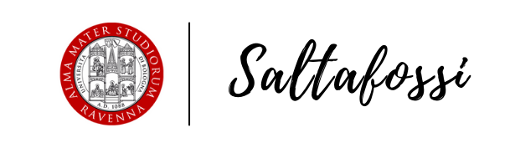

Title

Student:
Curse of study:

Abstract
Insert here your abstract

Summary
Introduction 1
Discussion 1
Conclusions 1
References 1

Introduction
Insert here your introduction

Discussion
Insert here your discussion

Conclusions
Insert here your conclusions

References
Insert here your references

