

ALMA MATER STUDIORUM

UNIVERSITÀ DI BOLOGNA

DEPARTMENT OF LEGAL STUDIES

ALMA HUMAN AI – CIRSFID

LAST-JD - Joint International Doctoral (PhD) Degree in Law, Science and Technology

**MARTIN EBERS**

(University of Tartu)

**“The Artificial Intelligence Act Proposal and its implications for consumers”**

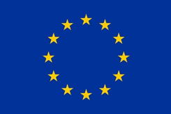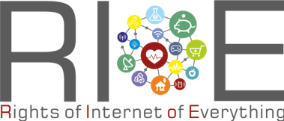

Legal Analytics for Italian LAw

April 4, 2022

*Seminars*

5.00 pm – 7.00 pm

Webinar, Microsoft Teams

E- Lecture via Microsoft Teams.   
Participation is free. Registration is required.   
Please, send an email to   
[federico.galli7@unibo.it](mailto:federico.galli7@unibo.it) to join

