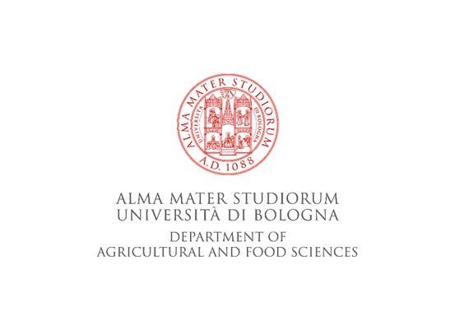

BUSCOB Strain request form*

Dr. Paola Mattarelli and Dr. Monica Modesto (Curators)
Bologna University Scardovi Collection of Bifidobacteria (BUSCOB)
Department of Agricultural and Food Sciences
University of Bologna
Viale Fanin 44
40127 Bologna
PHONE: +39 051 209 6267/6282
Email: paola.mattarelli@unibo.it

Species | Strain number | Number of strains

Please send us the BUSCOB strain(s) above listed for the following use (please indicate the reason of request)

Invoice address
Institution name:
Department:
Address:
Contact Name:
E-Mail:
Phone:
Name of the scientific Responsible of the research

Shipping address (if different from above)
Institution name:
Department:
Address:

Place and date
Signature
Name of the signature

*Please list the species and the number of strain(s) requested, write this document in all its parts and send it via e-mail (with electronic signature). The order will be taken in charge only after the receipt of the present document.

